Update for key stakeholders
25 November 2022

Vaccination
As at 20 November, vaccination figures across the whole of the NHS Highland area were:
 | Over 65s % complete | Health & social care staff % complete | 5-65s at risk % complete
COVID | 82.1 | 44.1 | 42.2
Flu | 76.1 | 42.5 | 38.2

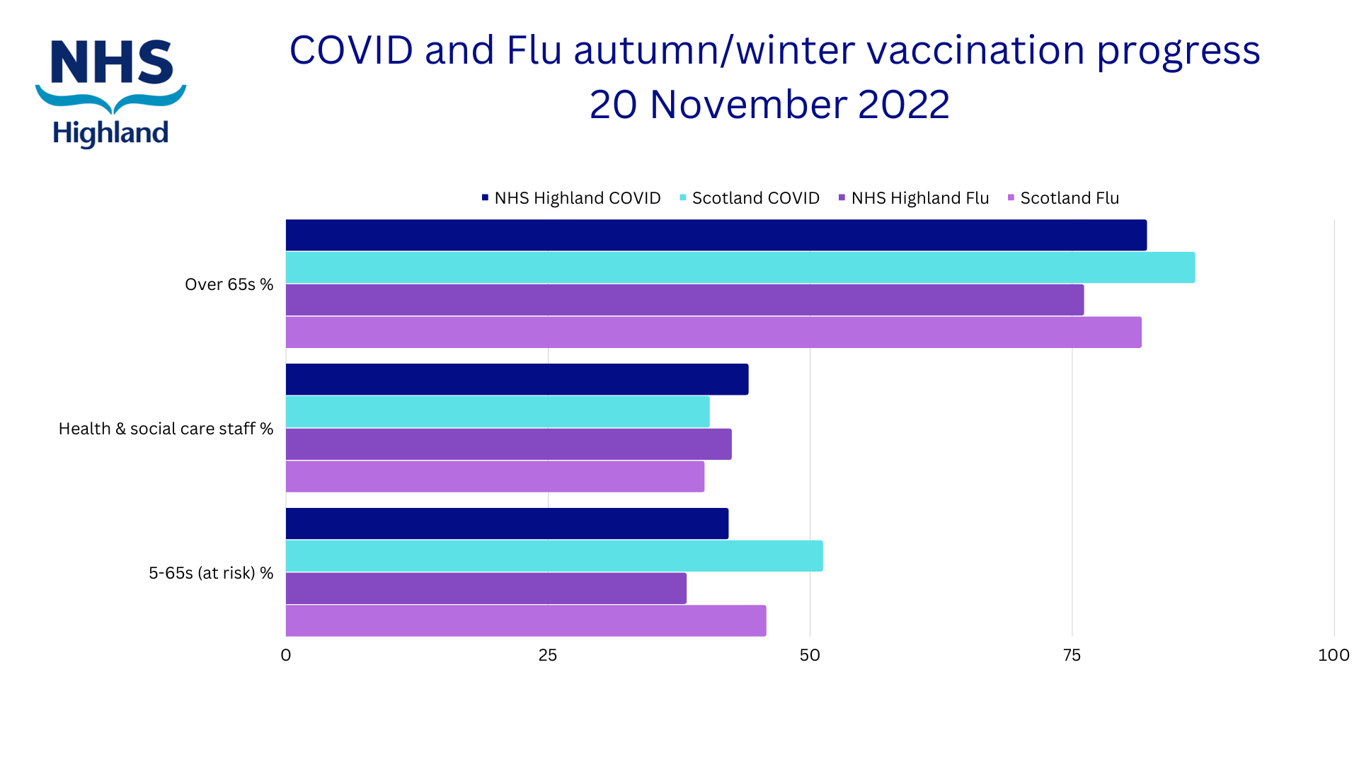
Board meeting
Our next board meeting will be on Tuesday 29 November at 9.30. It is open to the public and you can join the meeting online here:
___________
Microsoft Teams meeting
Join on your computer or mobile app
Click here to join the meeting
Join with a video conferencing device
28485375@t.plcm.vc
Video Conference ID: 129 681 681 6
Alternate VTC instructions
Learn More | Meeting options
_________________________________________________________________

Feedback
If you have comments or queries please contact nhshighland.feedback@nhs.scot

